Group A

Lab Assignment 2a

Sqoop

Importing Data set into Sqoop

74.

sqoop-import --connect jdbc:mysql://sandbox-hdp.hortonworks.com/hive --username root --P --table TBLS --target-dir /sqooplab/sqoop4 --fields-terminated-by '|' --num-mappers 7

Here we can see seven mapped files, since 7 mappers were used.

95.

If there’s already a sqoop folder of same name it will give error while executing so “**—delete-target-dir**” will delete the directory if any and create new one.

97.

**Free-form Query Imports**

Sqoop can also import the result set of an arbitrary SQL query. Instead of using the --table, --columns and --where arguments, you can specify a SQL statement with the --query argument.

When importing a free-form query, you must specify a destination directory with --target-dir.

Here we are importing only **75 data using conditions**

102.

Sqoop offers sql ClI as well it is accessed using **mysql -u root -p**

Password: **hortonworks1**

103. General sql command to insert into database.

104. importing under sqoop/empl directory and splitted by id.

106.Additional data added into table incr_tbl

107. Incremental append by checking value of id.

108. Four More mapper were added from sqoop import from picture 107.

109. a 12 rows in table incr_tbl.

109.b update column name where id=2.

110.Doing the incremental append again the update value wont reflect.

111. We can see that value in row 2 is not updated so we have to take argument last modified while importing.

112.

114. Select 5 row from table TBLS from hive database.

115.

IN MYSQL THERE IS A DB CALLED HIVE AND UNDER HIVE DB I have TXNS table which I use to import to Hive and name it as employee

116.Use hive and show databases. We can see hive data base there

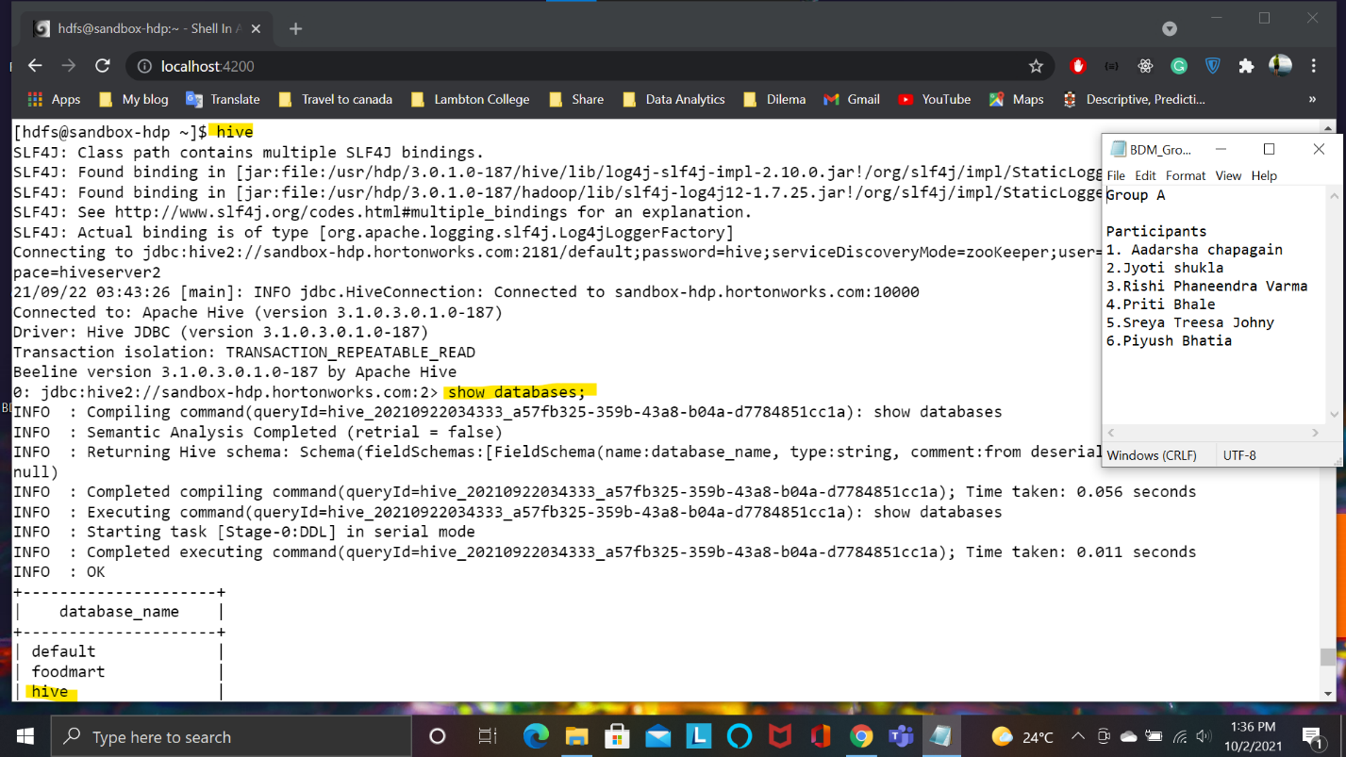

117. Show tables and explore employees table to show the structure.